**INSERTING VALUES ONLY SPECIFIC COLUMN**

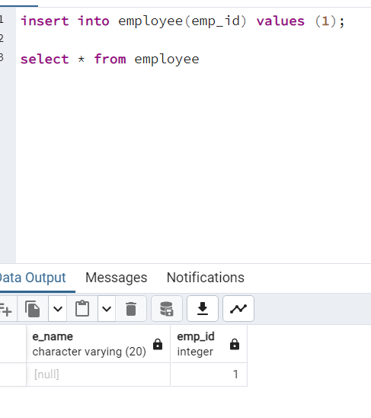

**NOT NULL CONSTRAIN AND DEFAULT CONSTRAINT**

